Dear Tenants:

As part of our ongoing effort to improve building services, Your Company Name is launching a work order and property management system called Prism, provided by Building Engines. This new program will allow you to enter service requests directly from your desktop, tablet or mobile device.

Keep an eye on your email for a Welcome email from Building Engines to activate your account.
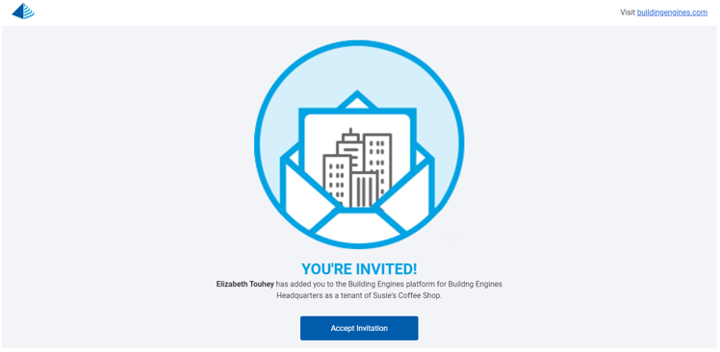

Just click “Accept” button and be brought to a page where you will see your username and create a password. Moving forward, you can use these credentials to log in and submit requests via connect.buildingengines.com.

Enclosed is a user guide which will explain how to enter a new work order via the web or Bengie™, Building Engines’ automated chatbot.

Thank you in advance for your participation and cooperation in making the Prism implementation a success at our properties. Should you have any questions about Prism, please feel free to contact your Property Manager directly, your contact information here.
.

Sincerely,

Your Signature here

